IoT- Assignment 1

Circuit: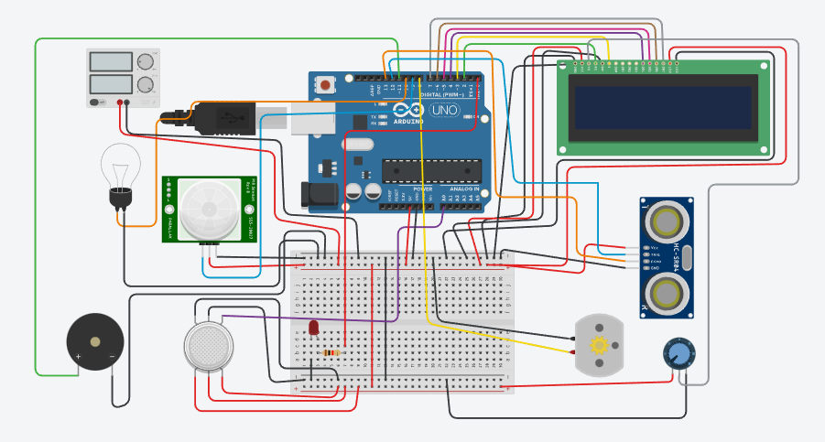

Program:

#include<LiquidCrystal.h>

LiquidCrystal lcd(2,3,4,5,6,7);

int trigPin = 12;

int echoPin = 13;

float travelTime;

float level;

float speed;//miles per hour

float readStatusofContainer(int trigPin,int echoPin)

{

//sending ping

digitalWrite(trigPin,LOW);

delayMicroseconds(100);

digitalWrite(trigPin,HIGH);

delayMicroseconds(10);

digitalWrite(trigPin,LOW);

return pulseIn(echoPin,HIGH);

}

int motorPin = 8;

int pirPin = 9;

int lightPin = 10;

int gasPin = A0;

int threshold = 400;

int buzzPin = 11;

int ledPin = 0;

void setup()

{

Serial.begin(9600);

lcd.begin(16,2);

pinMode(trigPin,OUTPUT);

pinMode(echoPin,INPUT);

pinMode(motorPin,OUTPUT);

pinMode(pirPin,INPUT);

pinMode(lightPin,OUTPUT);

pinMode(gasPin,INPUT);

pinMode(buzzPin, OUTPUT);

pinMode(ledPin,OUTPUT);

}

void loop()

{

travelTime = readStatusofContainer(trigPin,echoPin);//microseconds

travelTime = travelTime/1000000;//seconds

travelTime = travelTime/3600;//hours

speed = 60.0;//miles per hour(86.4 for 5 inches)

level = speed \* travelTime;//miles

level = level/2;//because travelTime is round trip time

level = level \* 63360;//inch

if(level <= 4.5)

{

//dispaly status

lcd.clear();

lcd.setCursor(0,0);

lcd.print("Trash Level:");

lcd.setCursor(0,1);

lcd.print(level);

lcd.print(" inches");

delay(100);

}

else

{

//dispaly status

lcd.clear();

lcd.setCursor(0,0);

lcd.print("Trash is full");

lcd.setCursor(0,1);

lcd.print(level);

lcd.print(" inches away");

delay(100);

}

travelTime = readStatusofContainer(trigPin,echoPin);//microseconds

travelTime = travelTime/1000000;//seconds

travelTime = travelTime/3600;//hours

speed = 240.1;//miles per hour(345.3 for 20 inches)

level = speed \* travelTime;//miles

level = level/2;//because travelTime is round trip time

level = level \* 63360;//inch

if(level <= 19.0)

{

//dispaly status and Turn on motor

digitalWrite(motorPin,HIGH);

lcd.clear();

lcd.setCursor(0,0);

lcd.print("Level: Motor");

lcd.setCursor(0,1);

lcd.print(level);

lcd.print(" in On");

delay(100);

}

else

{

//dispaly status and Turn off motor

digitalWrite(motorPin,0);

lcd.clear();

lcd.setCursor(0,0);

lcd.print("Level: Motor");

lcd.setCursor(0,1);

lcd.print(level);

lcd.print(" in Off");

delay(100);

}

if(digitalRead(pirPin)==HIGH)

digitalWrite(lightPin, HIGH);

else

digitalWrite(lightPin, LOW);

delay(100);

// \*\*\* Detects flammable gases \*\*\*

if(analogRead(gasPin) >= threshold)

{

digitalWrite(ledPin,HIGH);

digitalWrite(buzzPin,HIGH);

}

else

{

digitalWrite(ledPin,LOW);

digitalWrite(buzzPin,LOW);

}

delay(100);

}